Preparation:)_ YASSEN EL-Adly.
[ The first Test
Choose the correct answer:_
1_What is the function of the gall bladder ?
a) Production of bile b) Storage of bile c) Absorption of nutrients
d) Filtration of blood
2- Which system is responsible for digestion and absorption?
a) Muscuioskeletal system b) Digestive system. c) Respiratory system
d) Cardiovascular system
3- Which of the following is part of the axial skeleton?
a) Femur b) Sternum. c) Clavicle d) Scapula
4_How many lumbar vertebrae are present in the human body?
a) 4. b)5. c) 7. d) 12
5. Which bone is known as a sesamoid bone in the hand?
a) Pisiform. b) Scaphoid. c) Lunate d) Capitate
6_What type of joint is the knee
a) Fibrous joint. b) Synovial joint c) Primary cartilaginous joint
d) Secondary cartilaginous joint -
7_Which muscle type is voluntary and striated?
a) Smooth muscle. b) Cardiac muscle c) Skeletal muscle.
d) non of the above
8_Which nervous system is responsible for decreasing heart rate and constricting the bronchi?
a) Sympathetic nervous system . b) Somatic nervous system .
d) Central nervous system . . c) Parasympathetic nervous system
9. What is the primary function of the sympathetic nervous system?
a) To decrease blood pressure b) To increase digestive movement and secretions c) To prepare the body for a "fight or flight" respons
d) To control voluntary muscles
10-How many thoracic spinal nerves are there
a) 8. b) 10. c) 12. d) 5
11-The parasympathetic nervous system?
a) Constricts the pupil b) Decreases respiratory secretions
c) Relaxes the musclesof the urinary bladder
d) Decreases the movement of the GIT.
12. What is the length of the pharynx?
a) 8-10 cm. b) 10_12cm
C)12_ 15 cm d) 15_18 cm
13- The length of the duodenum is
a) 15cm. b) 20cm. c) 25cm. d) 30cm
14- The combined length of the jejunum and ileum is...
a) 3 meters b) 6 meters c) 9 meters
d) 12meters
15_What is the length of the appendix
. a) 2_10cm b) 2-15cm . c) 2-20 cm. . d) 5-25 cm
16_What are the dimensions of the kidney
a) 10 x 5 x 2 cm
b) 11 x 6 x 3 cm
c) 12 x 8 x 4 cm
d) 15 x 9 x 5cm
17-Which aystent is involved in gas exchange and gleetion?
a)Digestive system. b) nervous system c) respiratory system d)Urinary system
18-What type of benes are the carpal and tarsal bones ?
a) long bones
b) Flat bones
c) Short bones
d) Sesamoid bones
19- What is the function of the periosteum?
a) Bone lengthening b) Sensory nerve supply and protection c) Blood formatiom. d)calcium storage
20-The lateral angle of the scapula articulates with thy head of which bone formatiom
a) Radius.
b)femur
c)Humerus
d) Clavicle

II- Write true or false

1-The diaphragm separates the superior surface of the liver from the lungs and heart. (√)

2-The cerebellum is part of the brain stem. (×)

3-The jejunum is longer than the ileum(×)

4. The male urethra is shorter than the female urethra(×)

5-The sutures of the skull are examples of cartilaginous joints(×)

6-The sympathetic nervous system decreases blood pres sure(×)

7- Cardiac muscles are voluntary and striated(×)

8- The axial skeleton includes the skull, vertebral columy, ınd pelvic girdle(×)

III- Mention (8 marks each):

A-Difference between arteries and veins
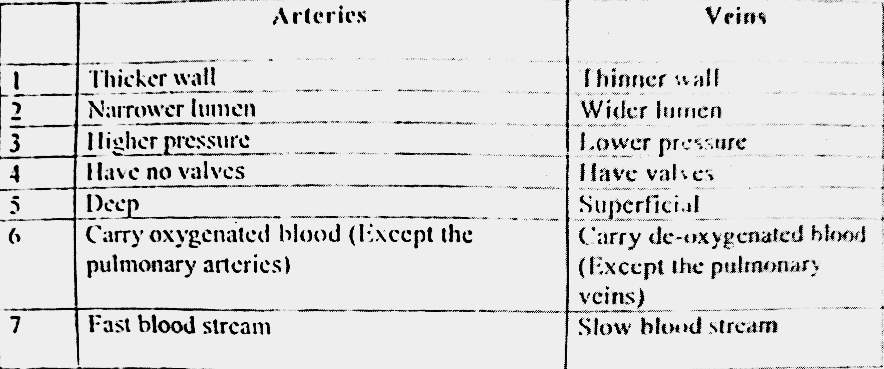
B- Difference between right and left lungs
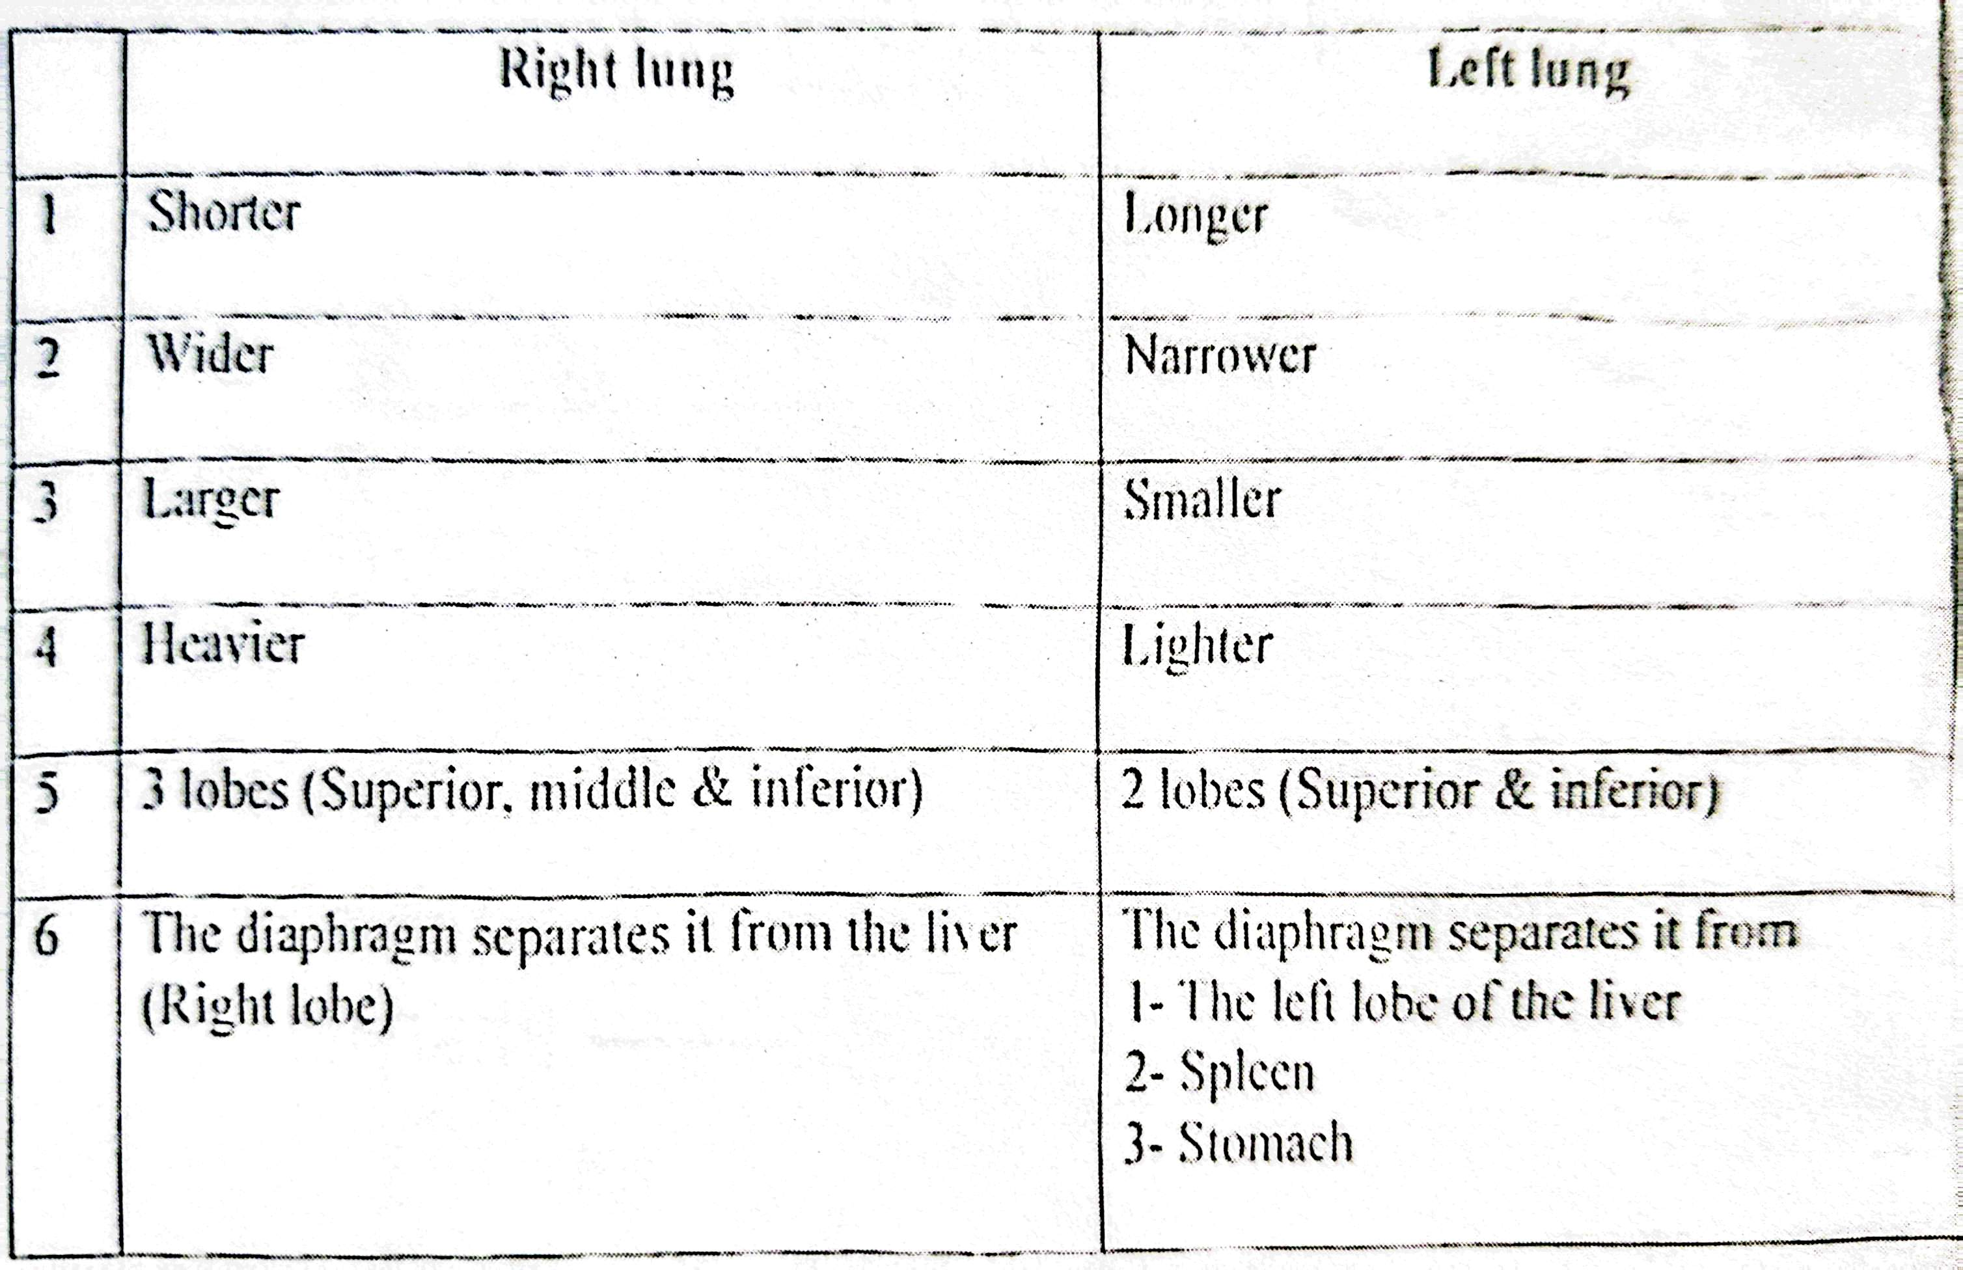

]The second exam [
Choose the correct answer (2 marks for each)

1- The parts of the axial skeleton include the
a- Humerus. b- Ribs c- Clavicle. d- Tibia
2- The scapula is a ...
a- Long b- Short c- Flat d- pneumatic
3-........ is stored in the bones
a- Calcium b- Iron. c- Blood. d- Vitamin D
4- The........ muscles are not striated
a- Smooth. b- Cardiac c- Voluntary
d- Skeletal
5- Biceps brachii muscle is....... In shape
a- Circular b- Triangular . c- Fusiform
d- Quadrangular
6- Sebaceous glands are not present in the skin of the
a- Scalp b- Palms of the hands. c- Back d- Face
7- The gall bladder stores the.....
a- Bile b- Blood c- Vitamins. d- Lipids
8- The ........... is located in the upper part of the abdomen
a- Appendix. b- Caecum c- Liver
d- Rectum
9- The ureter is......... cm long
a- 5 b- 10. c- 15 d-25
10- The gall bladder is located below the
a- Stomach b- Pancreas. c- Duodenum. d-liver
11- The right lungs consistes of ........ Lobes
a-2. b-3 c-4 d-5
12- The right lung is......... than the left lung
a- Longer b- Heavier c- Smaller d- Narrower
13- The......is the bone of the thigh
a- Humerus b- Tibia. c- Femur d- Radius
14- The heart consists of
a-2. b-3. c-4 d-5
............is the lowermost part of the brain 15
a- Medulla oblongata b- Pons
d- Midbrain. C)Diencephalon-
16- The ureter connects the......With the urinary bladder
a-Liver.
b- Kidney
c-pancereas
d- Right lung
.... .nerve supplies the muscles of the tongue. ....... _ 17
a- Facial. b- Optic c- Lingual d- Hypoglossal
18emerges from the left ventricle-
a- Aorta b- Inferior vana cava c- Superior vena cava. d- Pulmonary trunk
19- Pancreas lies behind the
a- Liver b- Left kidney. c- Spleen
d- Stomach.
20- The ileum opens into the....
a- Transverse colon
b- Stomach
c- Caecum
d- Appendix

Write true or false (2 marks each):
1- The synovial joints are freely mobile(√)
2- The kidney is located in the upper part of the abdomen(√)
3- The fibula shares in weight bearing(×)
4- Sympathetic stimulation decreases the heart rate(×)
5- The liver stores bile(×)
6- The esophagus is 25 cm long(√)
7- The blood is formed in the bone marrow(√)
8- The larynx consists mainly of bones(×)

Mention ):

1- Functions of bones
protects the internan argan
? Gives the body its shape
- suppafts the body during sittine
starage of cal cium
lengthening of the bedy.
2- Parts of the respiratory system
1_Nose
2_Pharynx
3_Larynx
4_Trachea
5_Bronchi
6_Lungs
3- Length & parts of the male urethra
Parts of male urethra:-
4 parts (Preprostatic, prostatic, membranous & penile
- The widest & most dilatable part is the prostatic part
- The narrowest & least dilatable part is the membranous part
- The narrowest point is the external urethral orifice

]The third exam]

1_ Bones of the axial skeleton.
1) skull.
2) vertebral column.
3) Sternum.
4) Ribs
- Parts of the brain stem.2
1) Midbrain
2) pons
3) Medulla oblongata
Parts of the small intestine
1) Duodenum
2) Jejunum
3)ileum

4- Function & capacity of the gall bladder.
Function #1. Storage of bile
Capacity #About 30–50 ml

5- Parts of the male urethra.
1. Prostatic urethra
2. Membranous urethra
3_penile



